SAVE A LIFE
– UNDERSTAND STROKE IDENTIFICATION:
During a BBQ, a friend stumbled and took a fall – flustered she assured everyone she was OK (they offered to call the ambo), she said she’d tripped on a brick.
They helped her to a chair and gave her another plate. While she appeared shaken, Ingrid apparently enjoyed herself for the rest of the lunch.
Her husband phoned later telling everyone that his wife had been taken to the hospital - (at 6:00 PM Ingrid passed away.) She had suffered a stroke at the BBQ.
A neurologist says that if he can get to a stroke victim within 3 hours he can totally reverse the effects ...totally... The trick is getting a stroke recognized, diagnosed, and the patient medically cared for within 3 hours.
RECOGNIZING A STROKE
Remember the 1st three letters of the word: S. T. R.
Recognize a stroke by asking three simple questions:
S Ask the individual to SMILE.
T Can the person TALK COHERENTLY - ask them to say a simple sentence e.g. “It’s warm in the sun today.”?
R Can the person RAISE BOTH ARMS?
If he or she has trouble with ANY ONE of these tasks, call 000 immediately and describe the symptoms.
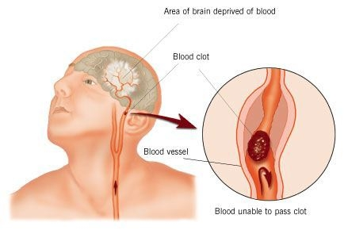
NOTE: Another 'sign' of a stroke is the tongue: Ask the person to 'stick' out their tongue.. If it’s 'crooked', goes to one side or the other, it’s an indication of a stroke.

